Assignment 9: Adversarial Training – Madry, TRADES, RAMP and FAT
CSC 592: Machine Learning Security and Privacy

Part 1: Theory Questions

The following theory questions are based on Lecture 9: Adversarial Training, the TRADES paper which can be found here: https://arxiv.org/abs/1901.08573 and the RAMP paper which can be found here: https://arxiv.org/abs/2402.06827. It is NOT necessary to read the papers before starting the questions, but it may be helpful to refer to the papers to find answers to certain questions.
Q1. In Madry’s adversarial training the optimization problem can be formulated as:
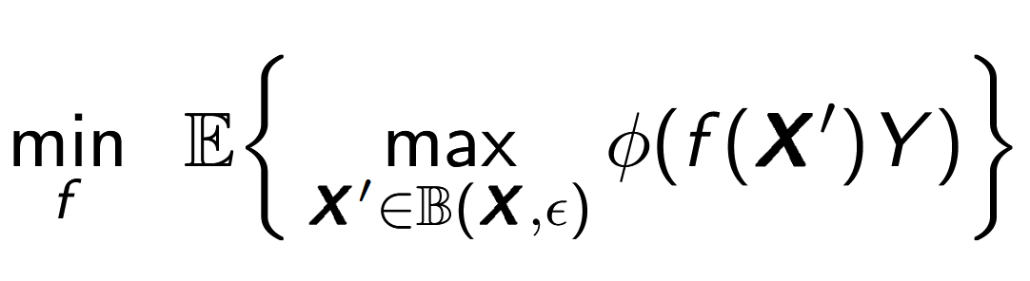
What is $f$, $X^{'}$and $φ$ in the above equation? In simple English, can you explain what this equation means?

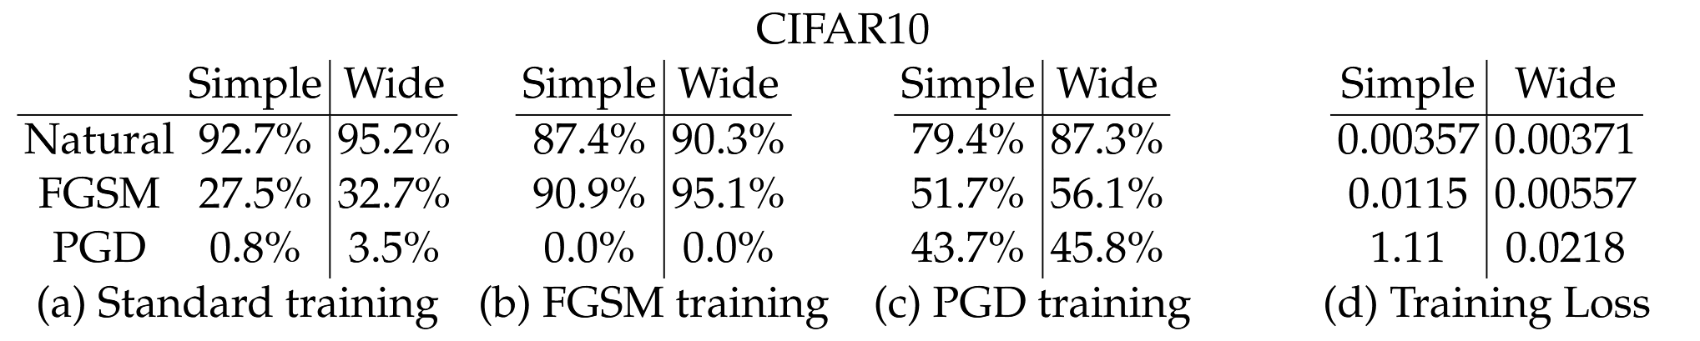

Figure Source: https://arxiv.org/abs/1706.06083
Q2. Based on the above table, which type of Madry’s training yielded the most robust model? What was the drop in clean accuracy that occurred when training the most robust model? Assume the baseline accuracy for CIFAR-10 is 92.7%.

Q3. From the “security researcher” perspective, why does adversarial training cause the clean accuracy of the model to decrease?

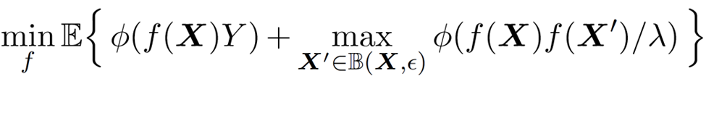
Q4. The above equation represents the TRADES optimization equation. Which part of the equation corresponds to ensuring the model has high clean accuracy? Which part of the equation corresponds to ensuring the model is robust to adversarial examples?

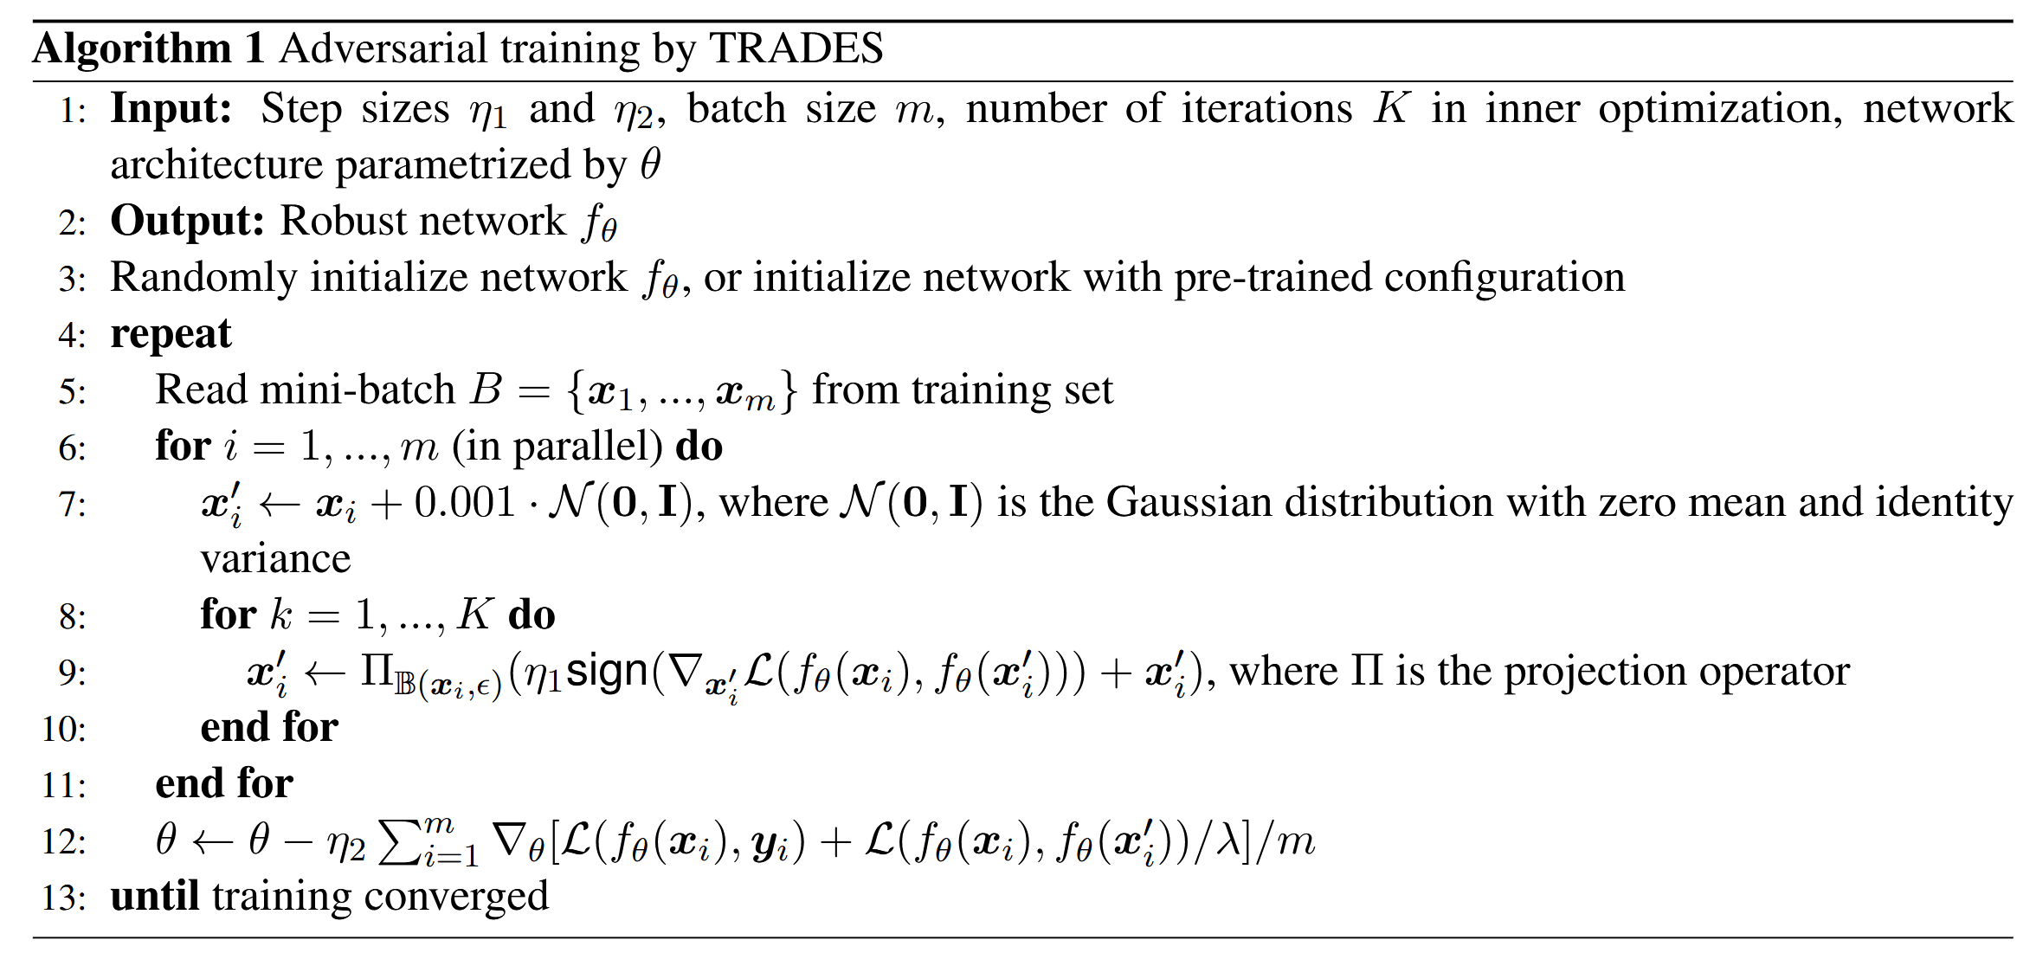
Figure Source: https://arxiv.org/abs/1901.08573
Q5. Part A: Read Algorithm 1 (shown above) carefully. What is the purpose of line 9?

Q5. Part B: In Algorithm 1 (shown above) what would be the effect of using a large value for the hyperparameter λ?

Q5. Part C: Consider two different training runs for algorithm 1. In the first run, we randomly initialize the weights of the model and train for 200 epochs with $K=10$. In the second run, we randomly initialize the weights of the model and train for 200 epochs with $K=1$. Which model would you expect to have higher robustness?

Q6. In lecture, both TRADES and RAMP were presented as ways to adversarially train a model. It was also mentioned in lecture that TRADES is one of the top performing adversarial training methods. Assuming this to be true, why do we need other adversarial training algorithms like RAMP?

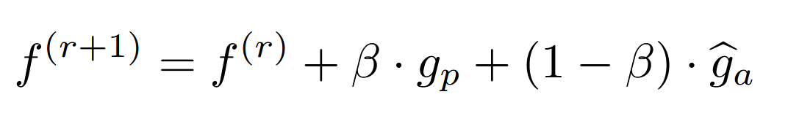
Q7. The update equation for RAMP is given above. In the equation which part of the update corresponds to gradients from adversarial examples and which part of the training corresponds to gradients from clean (natural) examples?

Part 2: Friendly Adversarial Training Coding Assignment

Background

In lecture we saw many defenses that were not robust to adversarial attacks. Training with adversarial examples is one type of defense that does offer some security against adversarial evasion attacks. In this part of the assignment, you will implement the Friendly Adversarial Training as developed in, “Attacks Which Do Not Kill Training Make Adversarial Learning Stronger”, by Jingfeng Zhang et al., published in ICML 2020 (https://arxiv.org/pdf/2002.11242).

In Friendly Adversarial Training (FAT), rather than employing adversarial examples that maximize the loss, the training algorithm searches for the least adversarial data (i.e., friendly adversarial data). It is easy to implement this technique by stopping the adversarial attack algorithm such as Projected Gradient Descent (PGD) early. The authors call this technique early-stopped PGD. The goal of FAT is to achieve adversarial robustness without significantly compromising the accuracy on clean examples (natural data).

Existing defense approaches employ a min-max optimization where typically PGD is used to generate the most adversarial data that maximizes the loss, before updating the current model. PGD perturbs the clean data for a fixed number of steps with a small step size. After each step of the perturbation, PGD projects the adversarial data back onto the-norm ball of the natural data. The authors of FAT show that this approach using a fixed number of PGD steps actually hurts the model’s performance on natural data. As an example, the following figure from the paper shows that from step #6 to #10 in PGD, the adversarial variants of the natural data significantly cross over the decision boundary and are located at their peer’s (natural data) area. When this adversarial perturbed data is used to train the model, it will significantly change the decision boundary hurting the natural accuracy.
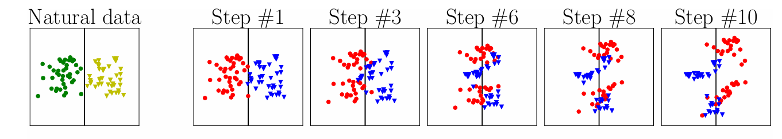
FAT employs early stopping of PGD so that the perturbed training data does not significantly cross the decision boundary. The steps allowed to cross the decision boundary are indicated by the parameter $τ$. Another parameter $K$indicates the maximum number of PGD steps allowed. This has the following effect in creating the adversarial perturbed data.
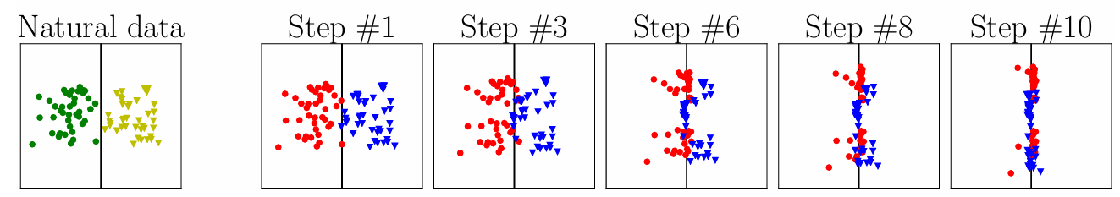
The FAT algorithm’s pseudo code appears below:
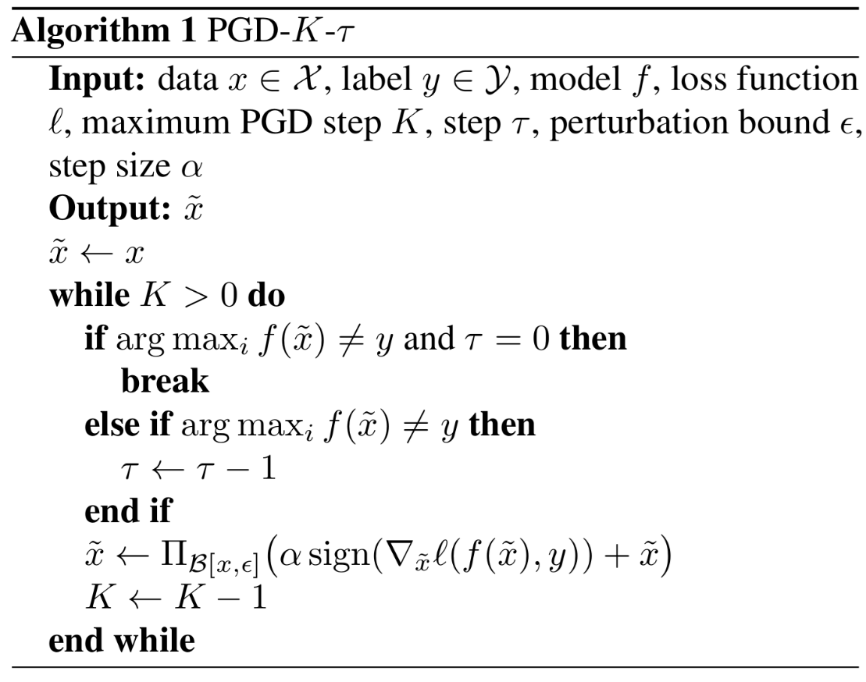
As can be seen from the above algorithm, to create a FAT adversarial example, either the number of steps are reached (e.g., $K = 10$, then $10$ PGD steps have completed), or $τ$ number of steps have occurred in which the sample is misclassified i.e., the input $x$ has become adversarial. For example, if $τ= 2$, and $K = 10$, and if after 5 PGD steps, the input $x$ becomes misclassified, then we will perturb the input two more times (provided, it continues to stay adversarial) before stopping the PGD algorithm.
Let us program this algorithm and test its clean and robust accuracy on CIFAR-10 for different attack algorithms such as FGSM, PGD-20 and Carlini and Wagner (C&W).
Step by Step Guide
Step 1: Create a project called FAT_CNN. Add a “checkpoints” and “models” folders to it. In the “models” folder, add a file called “NetworkCNN.py” with the following code in it. This is a simple multi-layer CNN.

from collections import OrderedDict
import torch.nn as nn
import torch
from torch.autograd import Variable

class NetworkCNN(nn.Module): # for CIFAR-10 : 3x32x32
def __init__(self):
super(NetworkCNN, self).__init__()

self.block1_conv1 = nn.Conv2d(3, 64, 3, padding=1)
self.block1_conv2 = nn.Conv2d(64, 64, 3, padding=1)
self.block1_pool1 = nn.MaxPool2d(2, 2)
self.batchnorm1_1 = nn.BatchNorm2d(64)
self.batchnorm1_2 = nn.BatchNorm2d(64)

self.block2_conv1 = nn.Conv2d(64, 128, 3, padding=1)
self.block2_conv2 = nn.Conv2d(128, 128, 3, padding=1)
self.block2_pool1 = nn.MaxPool2d(2, 2)
self.batchnorm2_1 = nn.BatchNorm2d(128)
self.batchnorm2_2 = nn.BatchNorm2d(128)

self.block3_conv1 = nn.Conv2d(128, 196, 3, padding=1)
self.block3_conv2 = nn.Conv2d(196, 196, 3, padding=1)
self.block3_pool1 = nn.MaxPool2d(2, 2)
self.batchnorm3_1 = nn.BatchNorm2d(196)
self.batchnorm3_2 = nn.BatchNorm2d(196)

self.activ = nn.ReLU()

self.fc1 = nn.Linear(196*4*4,256)
self.fc2 = nn.Linear(256,10)

def forward(self, x):
#block1
x = self.block1_conv1(x)
x = self.batchnorm1_1(x)
x = self.activ(x)
x = self.block1_conv2(x)
x = self.batchnorm1_2(x)
x = self.activ(x)
x = self.block1_pool1(x)

#block2
x = self.block2_conv1(x)
x = self.batchnorm2_1(x)
x = self.activ(x)
x = self.block2_conv2(x)
x = self.batchnorm2_2(x)
x = self.activ(x)
x = self.block2_pool1(x)
#block3
x = self.block3_conv1(x)
x = self.batchnorm3_1(x)
x = self.activ(x)
x = self.block3_conv2(x)
x = self.batchnorm3_2(x)
x = self.activ(x)
x = self.block3_pool1(x)

x = x.view(-1,196*4*4)
x = self.fc1(x)
x = self.activ(x)
x = self.fc2(x)
return x

Step 2: Add a file called earlystop.py to the project’s main folder with the following code in it. This file implements the FAT algorithm:
from models import *
import torch
import numpy as np
import torch.nn as nn

def earlystop(model, data, target, step_size, epsilon, perturb_steps,tau,randominit_type,loss_fn,rand_init=True,omega=0):
'''
The implematation of early-stopped PGD
Following the Alg.1 in FAT paper <https://arxiv.org/abs/2002.11242>
:param step_size: the PGD step size
:param epsilon: the perturbation bound
:param perturb_steps: the maximum PGD step
:param tau: the step controlling how early we stop when wrong adv data is found
:param randominit_type: To decide the type of random inirialization (random start for searching adv data)
:param rand_init: To decide whether to initialize adversarial sample with random noise (random start for searching adv data)
:param omega: random sample parameter for adv data generation (this is for escaping the local minimum.)
:return: output_adv (friendly adversarial data) output_target (targets), output_natural (the corresponding natrual data), count (average backword propagations count)
'''
model.eval()

K = perturb_steps
count = 0
output_target = []
output_adv = []
output_natural = []

control = (torch.ones(len(target)) * tau).cuda()

# Initialize the adversarial data with random noise
if rand_init:
if randominit_type == "normal_distribution_randominit":
iter_adv = data.detach() + 0.001 * torch.randn(data.shape).cuda().detach()
iter_adv = torch.clamp(iter_adv, 0.0, 1.0)
if randominit_type == "uniform_randominit":
iter_adv = data.detach() + torch.from_numpy(np.random.uniform(-epsilon, epsilon, data.shape)).float().cuda()
iter_adv = torch.clamp(iter_adv, 0.0, 1.0)
else:
iter_adv = data.cuda().detach()

iter_clean_data = data.cuda().detach()
iter_target = target.cuda().detach()
output_iter_clean_data = model(data)

while K>0:
iter_adv.requires_grad_()
output = model(iter_adv)
pred = output.max(1, keepdim=True)[1]
output_index = []
iter_index = []

# Calculate the indexes of adversarial data those still needs to be iterated
for idx in range(len(pred)):
if pred[idx] != iter_target[idx]:
if control[idx] == 0:
output_index.append(idx)
else:
control[idx] -= 1
iter_index.append(idx)
else:
iter_index.append(idx)

# Add adversarial data those do not need any more iteration into set output_adv
if len(output_index) != 0:
if len(output_target) == 0:
# incorrect adv data should not keep iterated
output_adv = iter_adv[output_index].reshape(-1, 3, 32, 32).cuda()
output_natural = iter_clean_data[output_index].reshape(-1, 3, 32, 32).cuda()
output_target = iter_target[output_index].reshape(-1).cuda()
else:
# incorrect adv data should not keep iterated
output_adv = torch.cat((output_adv, iter_adv[output_index].reshape(-1, 3, 32, 32).cuda()), dim=0)
output_natural = torch.cat((output_natural, iter_clean_data[output_index].reshape(-1, 3, 32, 32).cuda()), dim=0)
output_target = torch.cat((output_target, iter_target[output_index].reshape(-1).cuda()), dim=0)

# calculate gradient
model.zero_grad()
with torch.enable_grad():
if loss_fn == "cent":
loss_adv = nn.CrossEntropyLoss(reduction='mean')(output, iter_target)
if loss_fn == "kl":
criterion_kl = nn.KLDivLoss(size_average=False).cuda()
loss_adv = criterion_kl(F.log_softmax(output, dim=1),F.softmax(output_iter_clean_data, dim=1))
loss_adv.backward(retain_graph=True)
grad = iter_adv.grad

# update iter adv
if len(iter_index) != 0:
control = control[iter_index]
iter_adv = iter_adv[iter_index]
iter_clean_data = iter_clean_data[iter_index]
iter_target = iter_target[iter_index]
output_iter_clean_data = output_iter_clean_data[iter_index]
grad = grad[iter_index]
eta = step_size * grad.sign()

iter_adv = iter_adv.detach() + eta + omega * torch.randn(iter_adv.shape).detach().cuda()
iter_adv = torch.min(torch.max(iter_adv, iter_clean_data - epsilon), iter_clean_data + epsilon)
iter_adv = torch.clamp(iter_adv, 0, 1)
count += len(iter_target)
else:
output_adv = output_adv.detach()
return output_adv, output_target, output_natural, count
K = K-1

if len(output_target) == 0:
output_target = iter_target.reshape(-1).squeeze().cuda()
output_adv = iter_adv.reshape(-1, 3, 32, 32).cuda()
output_natural = iter_clean_data.reshape(-1, 3, 32, 32).cuda()
else:
output_adv = torch.cat((output_adv, iter_adv.reshape(-1, 3, 32, 32)), dim=0).cuda()
output_target = torch.cat((output_target, iter_target.reshape(-1)), dim=0).squeeze().cuda()
output_natural = torch.cat((output_natural, iter_clean_data.reshape(-1, 3, 32, 32).cuda()),dim=0).cuda()
output_adv = output_adv.detach()
return output_adv, output_target, output_natural, count
Step 3: Add a file to the main project’s folder called “attackgenerator.py” with the following code in it. This file implements the different attack algorithms such as FGSM, PGD and C&W.

import numpy as np
from models import *
import torch
import torch.nn as nn
from torch.autograd import Variable

def cwloss(output, target,confidence=50, num_classes=10):
# Compute the probability of the label class versus the maximum other
# The same implementation as in repo CAT https://github.com/sunblaze-ucb/curriculum-adversarial-training-CAT
target = target.data
target_onehot = torch.zeros(target.size() + (num_classes,))
target_onehot = target_onehot.cuda()
target_onehot.scatter_(1, target.unsqueeze(1), 1.)
target_var = Variable(target_onehot, requires_grad=False)
real = (target_var * output).sum(1)
other = ((1. - target_var) * output - target_var * 10000.).max(1)[0]
loss = -torch.clamp(real - other + confidence, min=0.) # equiv to max(..., 0.)
loss = torch.sum(loss)
return loss

def pgd(model, data, target, epsilon, step_size, num_steps,loss_fn,category,rand_init):
model.eval()
if category == "trades":
x_adv = data.detach() + 0.001 * torch.randn(data.shape).cuda().detach() if rand_init else data.detach()
if category == "Madry":
x_adv = data.detach() + torch.from_numpy(np.random.uniform(-epsilon, epsilon, data.shape)).float().cuda() if rand_init else data.detach()
x_adv = torch.clamp(x_adv, 0.0, 1.0)
for k in range(num_steps):
x_adv.requires_grad_()
output = model(x_adv)
model.zero_grad()
with torch.enable_grad():
if loss_fn == "cent":
loss_adv = nn.CrossEntropyLoss(reduction="mean")(output, target)
if loss_fn == "cw":
loss_adv = cwloss(output,target)
loss_adv.backward()
eta = step_size * x_adv.grad.sign()
x_adv = x_adv.detach() + eta
x_adv = torch.min(torch.max(x_adv, data - epsilon), data + epsilon)
x_adv = torch.clamp(x_adv, 0.0, 1.0)
return x_adv

def eval_clean(model, test_loader):
model.eval()
test_loss = 0
correct = 0
with torch.no_grad():
for data, target in test_loader:
data, target = data.cuda(), target.cuda()
output = model(data)
test_loss += nn.CrossEntropyLoss(reduction='mean')(output, target).item()
pred = output.max(1, keepdim=True)[1]
correct += pred.eq(target.view_as(pred)).sum().item()
test_loss /= len(test_loader.dataset)
log = 'Natrual Test Result ==> Average loss: {:.4f}, Accuracy: {}/{} ({:.2f}%)'.format(
test_loss, correct, len(test_loader.dataset),
100. * correct / len(test_loader.dataset))
# print(log)
test_accuracy = correct / len(test_loader.dataset)
return test_loss, test_accuracy

def eval_robust(model, test_loader, perturb_steps, epsilon, step_size, loss_fn, category, rand_init):
model.eval()
test_loss = 0
correct = 0
with torch.enable_grad():
for data, target in test_loader:
data, target = data.cuda(), target.cuda()
x_adv = pgd(model,data,target,epsilon,step_size,perturb_steps,loss_fn,category,rand_init=rand_init)
output = model(x_adv)
test_loss += nn.CrossEntropyLoss(reduction='mean')(output, target).item()
pred = output.max(1, keepdim=True)[1]
correct += pred.eq(target.view_as(pred)).sum().item()
test_loss /= len(test_loader.dataset)
log = 'Attack Setting ==> Loss_fn:{}, Perturb steps:{}, Epsilon:{}, Step dize:{} \n Test Result ==> Average loss: {:.4f}, Accuracy: {}/{} ({:.2f}%)'.format(loss_fn,perturb_steps,epsilon,step_size,
test_loss, correct, len(test_loader.dataset),
100. * correct / len(test_loader.dataset))
test_accuracy = correct / len(test_loader.dataset)
return test_loss, test_accuracy
Step 4: Add another file to the project called “train.py” with the following code in it. It has the standard training code to train the model:
import os
import torch.nn as nn
import datetime
import torch
from earlystop import earlystop

def train(model, train_loader, optimizer, tau, args):
starttime = datetime.datetime.now()
loss_sum = 0
bp_count = 0
for batch_idx, (data, target) in enumerate(train_loader):
data, target = data.cuda(), target.cuda()

# Get friendly adversarial training data via early-stopped PGD
output_adv, output_target, output_natural, count = earlystop(model, data, target, step_size=args.step_size, epsilon=args.epsilon, perturb_steps=args.num_steps, tau=tau,
randominit_type="uniform_randominit", loss_fn='cent', rand_init=args.rand_init, omega=args.omega)
bp_count += count
model.train()
optimizer.zero_grad()
output = model(output_adv)

# calculate standard adversarial training loss
loss = nn.CrossEntropyLoss(reduction='mean')(output, output_target)

loss_sum += loss.item()
loss.backward()
optimizer.step()

bp_count_avg = bp_count / len(train_loader.dataset)
endtime = datetime.datetime.now()
time = (endtime - starttime).seconds

return time, loss_sum, bp_count_avg

def adjust_tau(epoch, dynamictau, args):
tau = args.tau
if dynamictau:
if epoch <= 50:
tau = 0
elif epoch <= 90:
tau = 1
else:
tau = 2
return tau

def adjust_learning_rate(optimizer, epoch, args):
"""decrease the learning rate"""
lr = args.lr
if epoch >= 60:
lr = args.lr * 0.1
if epoch >= 90:
lr = args.lr * 0.01
if epoch >= 110:
lr = args.lr * 0.005
for param_group in optimizer.param_groups:
param_group['lr'] = lr

def save_checkpoint(state, checkpoint_dir='checkpoints', filename='checkpoint.pth.tar'):
filepath = os.path.join(checkpoint_dir, filename)
torch.save(state, filepath)
Step 5: Change the name of the main file to “FAT_CNN_main.py” and type the following code in it.
import sys
import os
import argparse
import torchvision
import torch.optim as optim
from torchvision import transforms
import datetime
from models import *
from earlystop import earlystop
import numpy as np
#from utils import Logger
import attack_generator as attack
import torch
from models.NetworkCNN import NetworkCNN
from train import train, adjust_learning_rate, adjust_tau, save_checkpoint

parser = argparse.ArgumentParser(description='PyTorch Friendly Adversarial Training')
parser.add_argument('--epochs', type=int, default=120, metavar='N', help='number of epochs to train')
parser.add_argument('--weight_decay', '--wd', default=2e-4, type=float, metavar='W')
parser.add_argument('--lr', type=float, default=0.1, metavar='LR', help='learning rate')
parser.add_argument('--momentum', type=float, default=0.9, metavar='M', help='SGD momentum')
parser.add_argument('--epsilon', type=float, default=0.031, help='perturbation bound')
parser.add_argument('--num_steps', type=int, default=10, help='maximum perturbation step K')
parser.add_argument('--step_size', type=float, default=0.007, help='step size')
parser.add_argument('--seed', type=int, default=7, metavar='S', help='random seed')
parser.add_argument('--net', type=str, default="networkcnn",
help="decide which network to use,choose from networkcnn,resnet18")
parser.add_argument('--tau', type=int, default=0, help='step tau')
parser.add_argument('--dataset', type=str, default="cifar10", help="choose from cifar10")
parser.add_argument('--rand_init', type=bool, default=True, help="whether to initialize adversarial sample with random noise")
parser.add_argument('--omega', type=float, default=0.001, help="random sample parameter for adv data generation")
parser.add_argument('--dynamictau', type=bool, default=True, help='whether to use dynamic tau')
parser.add_argument('--out_dir', type=str, default='./FAT_results', help='dir of output')
parser.add_argument('--resume', type=str, default='', help='whether to resume training, default: None')

args = parser.parse_args()

def main():
# training settings
torch.manual_seed(args.seed)
np.random.seed(args.seed)
torch.cuda.manual_seed_all(args.seed)

out_dir = args.out_dir
if not os.path.exists(out_dir):
os.makedirs(out_dir)

# setup data loader
transform_train = transforms.Compose([
transforms.RandomCrop(32, padding=4),
transforms.RandomHorizontalFlip(),
transforms.ToTensor(),
])
transform_test = transforms.Compose([
transforms.ToTensor(),
])

print('==> Load Test Data')
if args.dataset == "cifar10":
trainset = torchvision.datasets.CIFAR10(root='./data', train=True, download=True, transform=transform_train)
train_loader = torch.utils.data.DataLoader(trainset, batch_size=128, shuffle=True, num_workers=2)
testset = torchvision.datasets.CIFAR10(root='./data', train=False, download=True, transform=transform_test)
test_loader = torch.utils.data.DataLoader(testset, batch_size=128, shuffle=False, num_workers=2)

print('==> Load Model')
if args.net == "networkcnn":
model = NetworkCNN().cuda()
net = "networkcnn"
# if args.net == "resnet18":
# model = ResNet18().cuda()
# net = "resnet18"
print(net)

model = torch.nn.DataParallel(model)
optimizer = optim.SGD(model.parameters(), lr=args.lr, momentum=args.momentum, weight_decay=args.weight_decay)

start_epoch = 0
# Resume
title = 'FAT train'
if args.resume:
# resume directly point to checkpoint.pth.tar e.g., --resume='./out-dir/checkpoint.pth.tar'
print('==> Friendly Adversarial Training Resuming from checkpoint ..')
print(args.resume)
assert os.path.isfile(args.resume)
out_dir = os.path.dirname(args.resume)
checkpoint = torch.load(args.resume)
start_epoch = checkpoint['epoch']
model.load_state_dict(checkpoint['state_dict'])
optimizer.load_state_dict(checkpoint['optimizer'])
else:
print('==> Friendly Adversarial Training')

test_nat_acc = 0
fgsm_acc = 0
test_pgd20_acc = 0
cw_acc = 0
best_epoch = 0
for epoch in range(start_epoch, args.epochs):
adjust_learning_rate(optimizer, epoch + 1, args)

#-----------------train----------------------------
train_time, train_loss, bp_count_avg = train(model, train_loader, optimizer, adjust_tau(epoch + 1, args.dynamictau, args), args)

#----------------------evaluate--------------------
loss, test_nat_acc = attack.eval_clean(model, test_loader)
loss, fgsm_acc = attack.eval_robust(model, test_loader, perturb_steps=1, epsilon=0.031, step_size=0.031,loss_fn="cent", category="Madry",rand_init=True)
loss, test_pgd20_acc = attack.eval_robust(model, test_loader, perturb_steps=20, epsilon=0.031, step_size=0.031 / 4,loss_fn="cent", category="Madry", rand_init=True)
loss, cw_acc = attack.eval_robust(model, test_loader, perturb_steps=30, epsilon=0.031, step_size=0.031 / 4,loss_fn="cw", category="Madry", rand_init=True)

print(
'Epoch: [%d | %d] | Train Time: %.2f s | BP Average: %.2f | Natural Test Acc %.2f | FGSM Test Acc %.2f | PGD20 Test Acc %.2f | CW Test Acc %.2f |\n' % (
epoch + 1,
args.epochs,
train_time,
bp_count_avg,
test_nat_acc,
fgsm_acc,
test_pgd20_acc,
cw_acc)
)
save_checkpoint({
'epoch': epoch + 1,
'state_dict': model.state_dict(),
'bp_avg': bp_count_avg,
'test_nat_acc': test_nat_acc,
'test_pgd20_acc': test_pgd20_acc,
'optimizer': optimizer.state_dict(),
})

if __name__ == "__main__":
sys.exit(int(main() or 0))

The overall project structure should appear as:
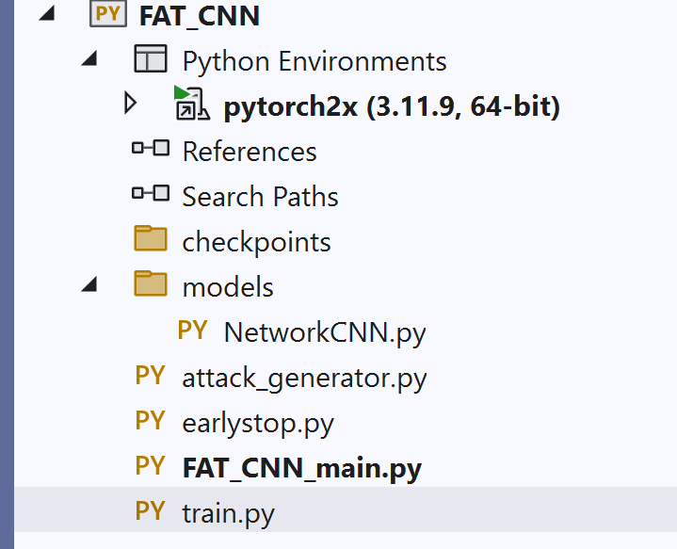
Step 6: Set the “FAT_CNN_main.py” as the startup file and run the project. On a computer with a GPU, it will take around 5-6 hours to complete the FAT training. The output should appear as:
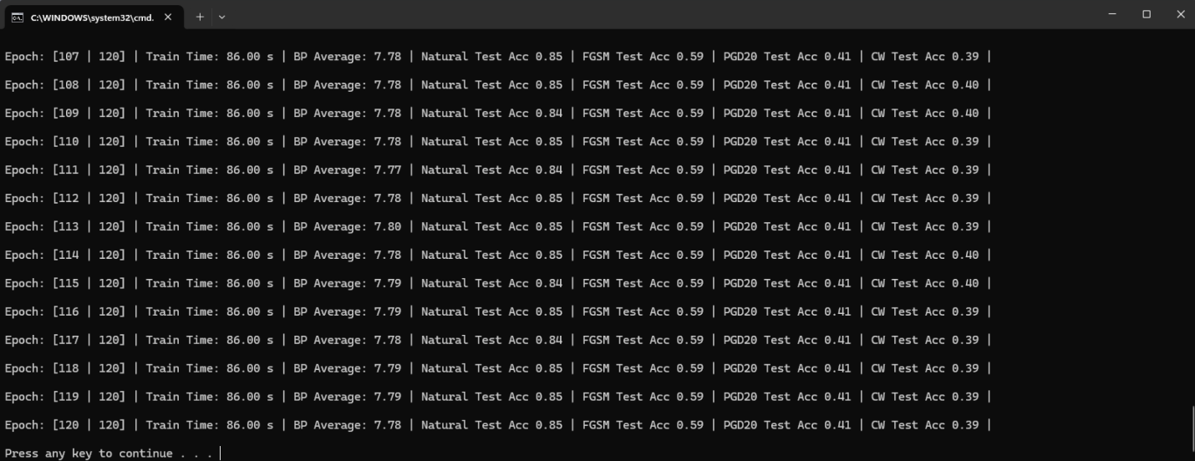
Deliverables
Submit the following three items on Brightspace:
Deliverable #1: A document containing the answers to the questions from part 1 of the assignment.
Deliverable #2: A screenshot of your code successfully training the FAT model and achieving a clean accuracy above 70% (Natural Test Acc).
Deliverable #3: A copy of your code (the .py files).

